ARENA 1 Gallery
A project of Santa Monica Art Studios
3026 Airport Avenue
Santa Monica, CA 90405
www.arena1gallery.com

GHOSTS

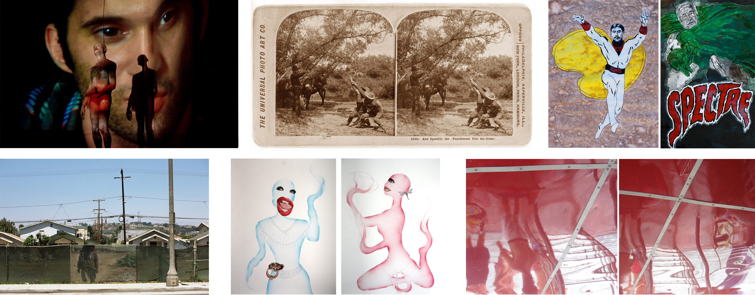

Susan Sontag: “In our digital hall of mirrors, the pictures aren’t going to go away.”

W.G. Sebald: “Remembrance, after all, in essence is nothing other than a quotation.”

EXHIBITION DATES: February 8 – May 1, 2014
OPENING RECEPTION: Saturday, February 8, 2014, 6:00 – 9:00pm
Special opening night performances by Prumsodun Ok (at 8pm)

Curated by Michael EB Detto and Sayon Syprasoeuth

Aragna Ker, denise a. scott, ken gonzales-day,
michael eb detto, prumsodun ok, sayon syprasoeuth

Arena 1 Gallery is pleased to present GHOSTS - a group exhibition,
curated by Michael EB Detto and Sayon Syprasoeuth, which gathers new work from six artists exploring the aftermath of the catastrophe, the genocide, or the war. How should we treat the Ghosts each of these leaves behind – in real life, as metaphor, as a tool?

The very own substantiality each one thing in itself exhibits, its innate properties, its relation to subject, time space, and language are altogether qualities which suddenly start to dissipate when we have to deal with ghosts. It is hard even to agree on one word for them: there are specters, phantoms and wreath, genie and spirit, the apparition and many other denominations to describe a phenomenon that tends to blur the demarcation line between subject and object, past and presence, here and there.
Cultural memory is collective memory, and the artist is part of it. Today’s notions of history and memory may be flawed and disputed, but they are especially problematic for the individual that experienced the disaster.
It was repeatedly noted: the silence of the victims – when they talk, the suffering will be stretched into the present day, making it unbearable.
To explore the roles of artists as storytellers and researchers, or as social advocates, artists are invited to talk and present their work. They are the descendants, therefore in a better position to face the past.

Initiated by Michael Detto’s project “Cambodian Ghosts”, Sayon Syprasoeuth and Michael Detto invite artists to a dialogue about their art and the ghosts of the past, and to present their work in this context.

There will be an exhibition walkthrough and conversation with the artists Sunday 12-2pm. discussing the themes (amongst others) ethics and art, beauty, style and the challenges of an esthetics of evil, and about the ghost in art.

Artists included are:

Aragna Ker: A native of Phnom Penh, Cambodia, Aragna Ker was born in 1974. He immigrated to Southern California in 1981, at the age of six. After graduating high school in Los Angeles, Ker relocated to attend San Francisco Art Institute and graduated with a BFA in Painting in 1999. In 2004, he received his MFA in Sculpture at Claremont Graduate University.

Essential experiences serve as springboard for Ker's methodology. His playful works fuse cultural symbols and myth to explore the vast range of hybrid identities. His drawings and sculptures utilize the potency of motive to curiously attack simplistic materials. The United States Embassy in Cambodia, The Hammer Museum, The Pacific Asian Art Museum, Happy Lion Gallery and Sabina Lee Gallery are just some of the establishments that he has exhibited in. Aragna Ker is currently employed as an Art Instructor at First Street Gallery Art Center (Claremont, CA), providing artistic instruction to adults with disabilities.

Denise A. Scott: Born in Pennsylvania and resides in Long Beach, CA and Phnom Penh, Cambodia. She earned a MFA in Sculpture from Indiana University of PA. With a twenty-five year exhibition record in venues in the US, Korea, Cambodia and U.K., she is noted for her large scale suspended egg installations, which is a symbol for the tomb and womb simultaneously. She has extended her repertoire into drawings and photography as her current Red Day series play on the reflections and inverted images that are tangled in the world beyond. In part, Scott’s work is currently on exhibit in the Art in Embassies Program, U.S. Department of State, Phnom Penh, Cambodia.

Ken Gonzales-Day: Ken Gonzales-Day's interdisciplinary and conceptually grounded projects consider the history of photography, the construction of race, and the limits of representational systems ranging from the lynching photograph to museum display.

His work has been exhibited internationally and is in numerous collections including: Smithsonian Institution AAM; Getty Research Institute; LACMA; Art Gallery of NWS; Los Angeles MTA; Santa Barbara Museum of Art; Eileen Harris Norton Foundation; L'Ecole des beaux-arts, Paris; among others. Monographs include: Lynching in the West: 1850-1935 (Duke, 2006) and Profiled (LACMA, 2011) . He is represented by Luis De Jesus Los Angeles.

Michael EB Detto: Born in West Berlin and grew up in northern Germany and in the black forest.
His passion for reading as a child introduced him to illustrated books with fairy tales and comics. That initiated passion for books, images and how they interact.
﻿ In 1984, Michael Detto began studying Humanities at the University of Hamburg for five years. His area of study included the Romance philology and Art History with an emphasis on the Italian Renaissance (Giorgione, Bellini and Raphael).

The main research Detto did was devoted to the way Dante’s work was reflected in Italian art (and conversely how Dante’s imagery anticipated time management in moving pictures); or how banderoles act in illuminated manuscripts and altar pieces.
﻿ Travels to museums in Italy, Spain, France, Scandinavia, the United States, Poland, Hungary, and Russia also were an integral part of Detto’s studies in Art History.
He recently had a solo show at Meta-House Cambodian-German Cultural Art Center, in Phnom Penh, Cambodia.

Prumsodun Ok: Works to positively transform our world through his practice as an artist, teacher, writer, and maker of things. His interdisciplinary performances contemplate René Daumal’s expression of “the avant-garde in antiquity,” mining the tradition of Khmer classical dance to explore the intersection of contemporary social issues with new possibilities for performance. His original works have been presented at REDCAT, Highways, CounterPULSE, KUNST-STOFF arts/fest, Pieter, CSU Long Beach University Art Museum, and the Culver Center as part of a joint conference hosted by the Society for Dance History Scholars and the Congress on Research in Dance.

Beyond his performance practice, Prum has directed and produced the SFAI Asian Performance Series in San Francisco and curated programs for INTERCITY (Phnom Penh), Anatomy Riot (Los Angeles), and Children of Refugees (Long Beach). He has been a featured speaker at the Association of Performing Arts Presenters Conference (APAP), UCLA, TED, as well as NYU as part of Season of Cambodia. His writings have been published by Salon.com, In Dance magazine, and featured by the California Dance Network. Prum is the grateful recipient of honors, grants, and fellowships from TED, the Association of Performing Arts Presenters (APAP), CHIME, Durfee Foundation, Center for Cultural Innovation, and the Alliance for California Traditional Arts (ACTA) among others. He is currently Associate Artistic Director of Khmer Arts and is the youngest member of ACTA’s Board of Directors.

Sayon Syprasoeuth: An interdisciplinary artist, focusing on his personal story as a refugee from Cambodia. He grew up in Thai refugee camps, and emigrated to the United States at the age of ten.
His work addresses past and present issues; triggered by memories of war and trauma, beliefs--spiritual dimensions and life in contemporary time in the United States.
His work has been shown in Cambodia, China, Berlin and throughout the United States.
He received his BFA from CSULB in 2003 and MFA from Claremont Graduate University (CGU) in 2007.

Since 2008 he has been a Coordinator for Global Hybrid; an arts exchange between artists in Cambodia, Korea and United States. He is currently an arts advisor for Applied Social Research Institute of Cambodia (ASRIC) a not-for-profit organization devoted to restoring, distributing, and implementing procedural justice for Cambodian American victims and survivors of the Khmer Rouge.

Curators

Michael EB Detto and Sayon Syprasoeuth: are artists living in Los Angeles and Irvine, California. This is their first curatorial exhibition together.

For more information please contact:
Michael EB Detto: dettonation@gmail.com 310.452.2247
Sayon Syprasoeuth: Syprasoeuth@yahoo.com 562.977.8966

ARENA 1 is an exhibition space founded by Santa Monica Art Studios directors Yossi Govrin and Sherry Frumkin. Based in an historic hangar at the Santa Monica Airport, ARENA 1 invites internationally known as well as newly established curators to develop innovative and compelling exhibitions.

